SCRRENSHOT IN GOOGLE CHROME

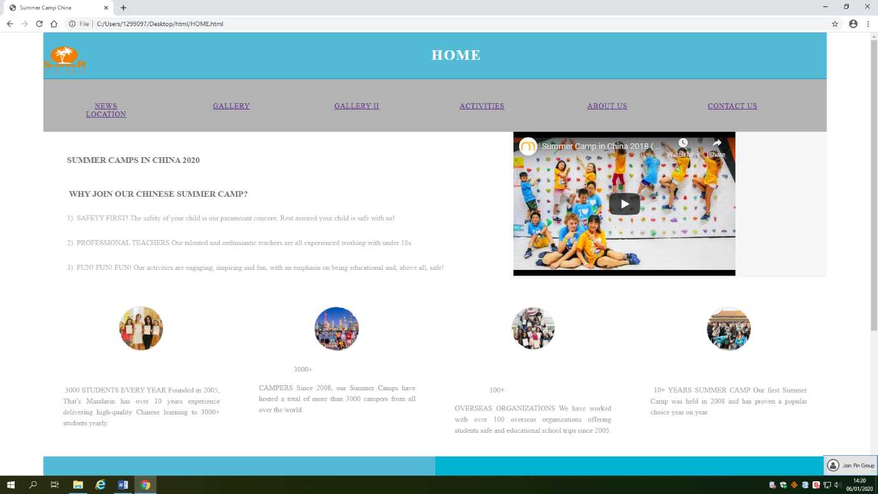HOME

NEWS

